**ll Om Sri Sai Ram ll**

**ll Om Sri Gurubhyo Namaha ll**

**CHILD BIRTH – ASTROLOGICAL REASONS**

**(Analysis based on Meena 2 Naadi System)**



**Prof. B. Hymavathi, PhD**

Prof. B Hymavathi PhD is from a famous astrologer’s family from Andhra Pradesh. HOD Yoga Samskrutham University, Florida, USA and Faculty, JKR Astro Research Foundation, Secunderabad. She is a disciple of Prof. Raja (Meena2 Jr.) and also the first secretary of JYSA (JKR-Yoga Samskrutham University Phd scholars Association). As a research supervisor she is guiding many Phd scholars. Written many articles in Light of Naadi astrology and in international magazines. Staunch supporter of Meena2 Naadi system and teaching the same to many as faculty JKRARF. She has successfully conducted 7 workshops of JYSA and introduced many Phd Scholars in Online meena2online platform. JKR ARF has published her thesis Planets Aspect and Reflection based on Meena2 Naadi principles in the year 2019 and her analysis is well received among astrologers’. She has received many honorary tiles like Jyothisa Choodamani, Divagna Ratna, Daivagna Shiromani, Jyothisa Acharya, etc. for her service to Meena2 Naadi system.

[hymaseshu.bhattar@gmail.com](mailto:hymaseshu.bhattar@gmail.com)

Marriage is a very important bonding in our life. But it is said that a child completes the family. Birth of the child brings about immense joy to the married couple.

**CHILD BIRTH - ASTROLOGY**

**HOUSES:** 5th house, 2nd house and 11 houses have to be analyzed for the child birth.

* 5th House is the primary bhava for children.
* 2nd House represents family.
* 11th House signifies labha & fulfilment of desires.

5th House is also the labha sthana to the 7th House.

**JUPITER** is the natural significator of Child Birth.

**SIGNS:** Out of 12 signs in the Zodiac, few signs are fertile and fruitful where as few signs are barren.

FERTILE SIGNS:All watery signs – Cancer, Scorpio, Pisces are fertile signs.

BARREN SIGNS**:** Aries, Gemini, Leo, Virgo are Barren signs.

SEMI FERTILE SIGNS: Taurus, Libra, Capricorn

SEMI BARREN SIGN: Aquarius

**FERTILE PLANETS & BARREN PLANETS**

* Fertile Planets: Jupiter, Venus, Sun, Moon and Rahu
* Barren Planets: Mars, Saturn, Ketu
* Mercury sometimes acts as fertile planet and sometimes as Barren.

**12 BHAVAS – CHILD BIRTH**

Let us look at all the 12 bhavas with reference to Child Birth.

* 2,5,11 Houses – Houses of Child Birth
* 9th House – Supports the houses of Child Birth, facilitator
* 1,4,10 Houses – Negates the event (Vyaya Bhavas (12th) of 2,5,11 houses).
* 6,8,12 Houses – Complications/miscarriages/abortions
* 3,7 Houses – Neutral

**PROMISE OF THE CHILD BIRTH**

* When 5th house or Jupiter is strongly connected to 2,5,11 houses and is favourably posited with benefic connections, child birth is promised in the horoscope.

**DELAY IN THE CHILD BIRTH**

* When 5th house or Jupiter is connected to maraka and badhaka sthanas or their lords, delay in the child birth is expected.
* When 5th house or Jupiter is connected to separative planets like Sun, Mars, Saturn, Rahu and Ketu, child birth is delayed.

**DENIAL OF THE CHILD BIRTH**

* When 5th house or Jupiter is strongly connected to 1,4,10 houses (houses negating the child birth) + Barren Planets + Barren signs – then child birth is denied.

**DASA-BHUKTHI-ANTARA**

When Dasa / Bhukthi / Antara signifies

* + 2,5,9,11 houses/Jupiter (for both male and female) – child birth is denoted
  + 6,8 or 8,12 houses + Mars/Ketu - Surgery
  + 6,8,12 houses – complications/difficulties during Pregnancy period
  + 6,8,12 houses + Rahu/Ketu/Saturn – promotes miscarriages/abortions
  + 1,4,10 houses – denial of the event

Dasa lord should at least be neutral (without denying the event). But Bhukthi lord should indicate the event very strongly.

**Example Chart**

**Male: 16.05.1977, 11.26.00, Nirmal, AP**

|  |  |  |  |
| --- | --- | --- | --- |
| Ma  Ve | Ke Mo Me | Su Ju |  |
|  | **Rasi Chart** | | **Asc**  Sa |
|  |  |
|  |  | Ra |  |

|  |  |  |  |  |  |
| --- | --- | --- | --- | --- | --- |
| **Planet** | **Sign** | **Degrees** | **Nakshatra** | **Qtr** | **Guna** |
| Ascendant | Cancer | 210 03’ | Aslesha | 2 | -- |
| Sun | Taurus | 010 42’ | Krittika | 2 | RRT |
| Moon | Aries | 110 21’ | Aswini | 4 | TSR |
| Mars | Pisces | 200 43’ | Revathi | 2 | SRT |
| Mercury | Aries | 110 23’ | Aswini | 4 | TRR |
| Jupiter | Taurus | 150 39’ | Rohini | 2 | RRR |
| Venus | Pisces | 200 41’ | Revathi | 2 | SRT |
| Saturn | Cancer | 170 29’ | Aslesha | 1 | SSS |
| Rahu | Libra | 000 38’ | Chitta | 3 | TRR |
| Ketu | Aries | 000 38’ | Aswini | 1 | TST |

**Analysis**

Native’s lagna is Cancer. In this horoscope, 5th lord Mars is conjoined with 11th lord (fulfilment of desires) Venus and posited in the 9th house (Yoga karaka house). Jupiter, significator of child birth is posited in the labha sthana (11th house) conjoined with 2nd lord (family) Sun. So, without any hesitation, one can easily say that the native has progeny. But native do not have progeny.

Let us look at the factors of native not having children.

Child birth – 5, 2, 11 houses and Jupiter.

In the horoscope, 5th lord Mars is conjoined with 11th lord Venus and posited in the yoga karaka house (9th house). 11th lord Venus is exalted as well. But planet posited in a house will not deliver the result. Its star lord delivers the result favourable or unfavourable. Guruji Sri. N. V. Raghavachary in his “Practical Stellar Astrology” book says, “Planet gives the result of its star lord and its connections”.

Here, 5th lord Mars and 11th lord Venus – both are posited in the constellation of Mercury. Star lord Mercury is conjoined with 1st lord Moon (which is negating the 2nd house of family) and Ketu, cutting master in the 10th house (negating 11th house of labha). Further Mercury, Moon and Ketu are all in the constellation of Ketu. Guruji Says, in general benefic planets in Ketu’s constellation will not yield good results. Moreover, Mercury is Lagnapadadhipathi and Moon is Lagnadhipathi. Lagna, itself is not strong.

Mercury and Moon both are conjoined with Ketu and posited in the star of Ketu. Out of all the planets Ketu is very powerful and strong. It is placed in its own house, in its own constellation and also gained digbala status in the 10th house. Further, it is barren planet posited in barren sign. All these planets are aspected by Saturn one more barren planet and 8th lord posited in the Lagna.

Let us look at the Putra karaka Jupiter. Jupiter is posited in the 11th house (labha sthana) conjoined with 2nd lord (family) Sun. There is also parivartana between Venus and Jupiter. But Jupiter is also posited in the star of Moon which is strongly influenced by cutting master and barren planet Ketu. As already mentioned earlier, Ketu is powerfully posited in the 10th house in barren house.

When the native got married on 21.08.2008 he was running Moon dasa and next Mars dasa. Both are controlled by Ketu. So, till now native is not blessed with children.

**TRANSIT**

Even though the event is promised in the birth chart and suitable DBA is running to the native, the event will not happen without favourable transit. DBA lords should favourably transit and also 5th house connected planets.

Here is a very simple and easy method to identify timing of child birth.

* **1 – Self;**
* **5 – Children;**
* **9 – Father**

They all belong to the same lineage and these houses are interlinked with each other.

**Jupiter** is the natural significator of child birth. So, when Transit Jupiter is connected to 1-5-9 houses child birth is indicated.

**Timing of child birth – Transit Jupiter**

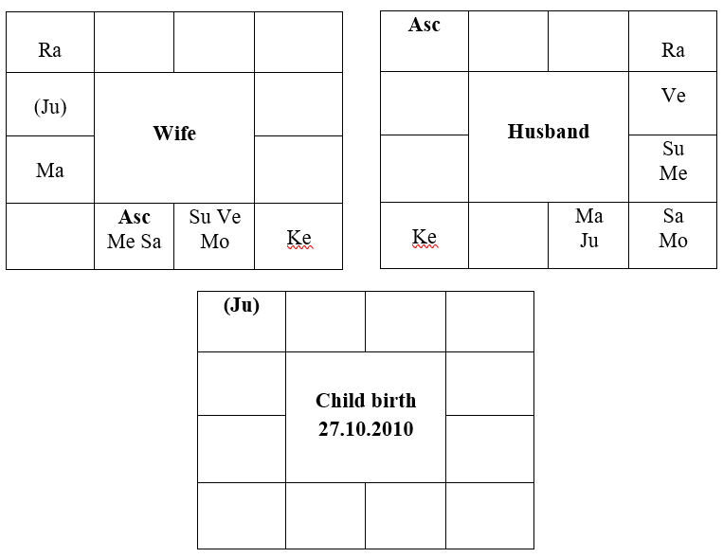

Wife – Transit Jupiter is transiting in the 5th house of wife’s horoscope and aspecting Lagna and 9th house.

Husband – Transit Jupiter is transiting in the Lagna and aspecting 5th house, 5th lord Moon and also 9th house.

One should not come to conclusion that benefic planets always bestow the native with benefic results and barren planets or barren houses do not confer the progeny. Any planet is capable of giving positive or negative result. They must be favourably placed in constellations. Before venturing into predictions, it is very important to study the planet’s strength, stellar lords, their connections, situation and also the guna acquired by the planet as they play an important role in influencing the nature of results.

II Samasta Lokah Sukhino Bhavantu II